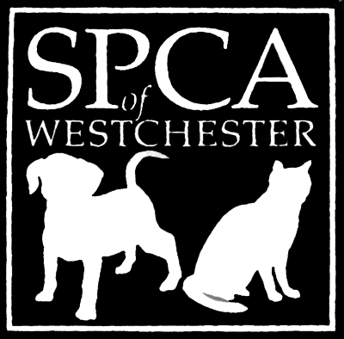
SPCA of Westchester, Inc.
590 North State Road, Briarcliff Manor, NY 10510

(914) 941-2896 Fax (914)762-8312
www.SPCA914.org
shelter@spca914.org

CAT APPLICATION FORM FOR FOSTER HOME CARE

In order to be considered for foster, the applicant must:
- Be at least 21 years of age
- Have legal identification with your current address
- Be able to verify that you are allowed to house cats where you live
- Must provide vet and/or personal references
- Must provide a copy of all household pets’ vaccine records attached to application

Today’s Date:_______________
Name:___________________________________________ Date of Birth:________________
Address:___________________________________________________
City:________________________________ State:__________ Zip code:_____________
E-Mail Address:___________________________________ Phone #:_________________________
Alt. Phone #:__________________________ How long have you lived at this address:____________
Do you currently live with a parent(s)? Y N *If yes, provide their information below*
Parent’s Name: ________________________________ Phone #:___________________________
Do you Own OR Rent a: House Apartment Condo/Co-op Other
*If you Rent or Own a condo/Co-op, you will be required to provide a copy of your lease/bi-laws that states you can own a pet. Otherwise, you are required to provide us with the phone # of your landlord/management company*
Landlord’s Name/Management Co:___________________________ Phone #:____________________
Have you adopted from the SPCA of Westchester before? Yes No When?_______________
Please list the names, ages and relation of all adults in the household:
____________________________________________________________________________________________________________________________________________________________________________________________________________________________________________________________

Please list the names, ages and relation of all children in the household:
____________________________________________________________________________________________________________________________________________________________________________________________________________________________________________________________

Does anyone in the household have allergies to cats? ________________________________________

What kind of experience have you had/have with cats? (vet tech, groomer, happy pet owner, etc). ________________________________________________________________________________________________________________________________________________________________________

Do you currently own any pets? If so, list names and ages of all household pets.
____________________________________________________________________________________________________________________________________________________________________________________________________________________________________________________________
* All household pets must be altered and up-to-date medically. Please provide a copy of your pets’ vaccine records along with this application.*

Do any household pets have health issues that can affect the foster cat? ________________________

Have you ever fostered an animal before? If so, what was your experience?
________________________________________________________________________________________________________________________________________________________________________

Where will the foster cat or kitten(s) stay during the day, at night, and when left alone?
____________________________________________________________________________________

Who will be the primary caretaker of the foster cat or kitten(s)?
____________________________________________________________________________________

Are you willing to have someone from the SPCA visit your home for a home visit? _________________

Are you willing to cover the costs of caring for a foster cat except for medical expenses? ____________
Are you able to transport the foster cat or kitten back to the SPCA for weekly check-ups? ____________

Please circle which fosters you are most interested in: Bottle Kittens Halfway kittens (5-8 weeks)
Pregnant & Nursing Mothers Feral & Timid Sick & Recovering Seniors
For a description of each, please refer back to the cat foster guide. *If you have not received and read the foster guide, please email cathi@spca914.org or ask office personnel for a copy prior to submitting the application*

If you currently, or within the past year, have owned a pet please provide the name of your veterinarian:
Name of Vet:_______________________________________________________
City:___________________________________ Phone #:______________________________
Please provide 2 Personal References. They should be either a work reference or a friend, NOT a family member or person you live with:
Name: _________________________________ How do you know this person:_______________
Phone #:________________________________
Name: _________________________________ How do you know this person:_______________
Phone #:________________________________

ALL OF THE INFORMATION I HAVE PROVIDED ON THIS APPLICATION IS, TO THE BEST OF MY KNOWLEDGE, TRUE AND COMPLETE. I UNDERSTAND THAT FALSIFYING ANSWERS ON THE APPLICATION, OR AT ANY OTHER TIME DURING THE FOSTERING PROCESS, DISQUALIFIES ME FROM FOSTERING.

Signature of applicant: _________________________________ Date: ___________________

FOSTER CARE AGREEMENT

I understand and agree to all information provided to me in the cat foster guide.
YES ______________ NO_______________
*If you have not received and read the foster guide, please email cathi@spca914.org or ask office personnel for a copy prior to submitting the application*

If during the time I am fostering the animal and it requires medical attention, I will contact the SPCA of Westchester.
YES ______________ NO_______________

I understand to keep the foster animal in my possession during the foster period. I will not give the animal to another party without the shelter’s consent. I will keep cats and kittens indoors.
YES ______________ NO_______________

I understand the foster animal is the property of the SPCA of Westchester and will not give away, sell, trade or dispose of the animal.
YES ______________ NO_______________

I understand that anyone interested in adopting my foster cat (including myself) must go through the standard adoption process, and approval of candidates and placement of animals is up to the SPCA of Westchester.
YES ______________ NO_______________

I understand that although the SPCA of Westchester takes reasonable care to screen animals for foster care placement, it makes no guarantee relating to the animals’ health, behavior or actions. I understand that I receive foster care animals at my own risk and can reject or return any animals for which the SPCA has asked me to provide care. I indemnify and hold the SPCA of Westchester free and harmless from all liability arising out of any and all claims, demands, losses, damages, action, judgment of every kind and description which may occur to or be suffered by me, members of my household, or any third parties by reason of activities arising out of this agreement. I release the SPCA of Westchester from responsibility for any diseases that may be contracted by my resident animal(s) from the foster animal.

_______________________________________ _____________________________________
Signature of Foster Parent SPCA of Westchester Representative
Date _______________________

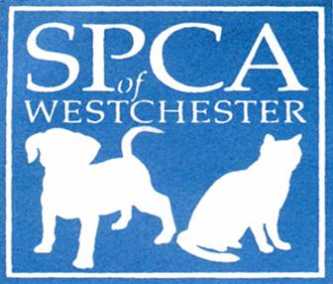
Medical Waiver

The SPCA of Westchester requires all household pets be current on vaccinations. All dogs require an up-to-date DHPP, Rabies, and Bordetella vaccine. All cats require an up-to-date FVRCP and Rabies vaccine.

I, ____________________________, state that my animals are currently vaccinated, and I agree to update their vaccines regularly. I understand that there is always a risk that foster animals can harbor contagious illnesses. I agree to keep foster pets separated from my own pets for the duration of their stay, for the health and safety of my own pets, as well as those in foster care. If I fail to do so and should they become ill as a result of the foster animal, I will assume all responsibility of any medical expense to my resident pets and will not hold the SPCA of Westchester accountable. Introducing household pets is not recommended and will be done at my own risk.

Print Name___________________________________
Signature_____________________________________ Date_________________

